Module Name: DemoQA Mobile Number input Field
Test Case ID: TC_LOGIN_001
Webpage URL: https://demoqa.com/automation-practice-form

Scenario ID: 1A
Scenario: Testing Mobile Number input field with a valid number
Test Steps:
- Open the DemoQA
- Click on Forms
- Choose Practice Form
- Enter Mobile Number in input field
- Click Submit Button
Screenshots :
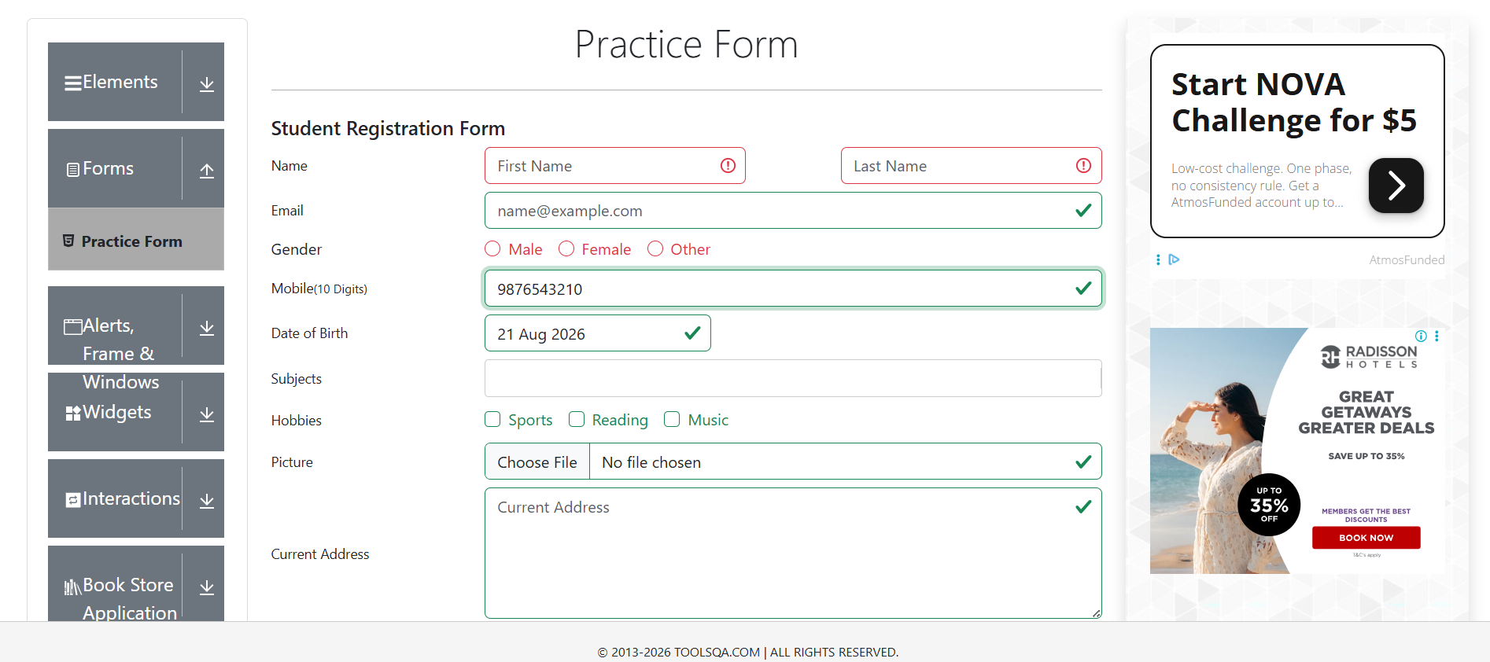

Scenario ID: 2A
Scenario: Testing Mobile Number input field with a invalid number
Test Steps:
- Open DemoQA
- Click on Forms
- Choose Practice Form
- Enter an invalid 9 digit Number
- Click Submit button
Screenshots :
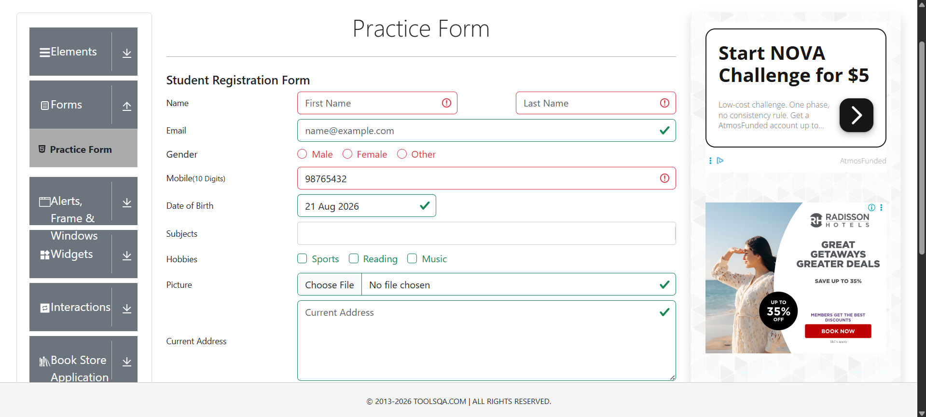

Scenario ID: 2B
Scenario: Testing Mobile Number input field with a invalid number
Test Steps:
- Open DemoQA
- Click on Forms
- Choose Practice Form
- Enter an invalid Number with letters
- Click Submit button
Screenshots :
